The goal is to convert that input into a business-ready semantic data product that reporting teams, analytics users, and later AI/agent use cases can consume in a consistent way. The meeting notes are very clear on this point: Hydra builds the underlying data assets, but the value your team adds is in turning those assets into a semantic data product instead of publishing them as-is.

Business purpose
The business purpose of this semantic data product is to provide a single, governed performance layer for market analytics. That means users should be able to look at performance by product, geography, writer/HCP, time, and business segmentation without rebuilding KPI logic in every dashboard.
In practical terms, this semantic product should support questions such as:
- How is a brand performing across geographies?
- How is performance changing over time?
- How does one product compare with another product or molecule?
- What is the share, depth, or writer activity for a given product?
- How does performance vary by alignment type, tier, or master profile?
That direction also matches the earlier meeting context that the business is asking analytical questions, while Hydra provides the underlying tables and your team builds the semantic product that makes the data usable.

How the semantic product should be organized
The cleanest way to think about this is:
- one central table stores the KPI values,
- surrounding dimensions describe the business context of that KPI,
- one metric catalog stores the KPI meaning and definition.

That is the real semantic value-add. We are not just copying the KPI sheet. We are organizing it into something that can be reused safely.

1. Core business dimensions
These should be modelled as dimensions because they describe the business context around the KPI:
- Division
- Brand
- Geography
- Alignment Type
- Tier Type
- Master Profile
- Period Type
- Time
- Comparison Product or Product Context

Even if “Geography” appears in the KPI list, it should semantically behave as a dimension, not as a measure.

2. KPI families
The KPI families visible from the screenshots should be governed in a consistent way. The main families appear to be:
- MOTRX
- NBRX
- Writers
- Share
- Depth
- Change metrics
These should not remain as giant hardcoded labels only. They should be normalized into structured business parts.

3. Metric catalog
This is one of the most important pieces.
Today the KPI names appear in forms like:
- Bimzelx MOTRX
- Cosentyx SC MOTRX SHARE
- Humira Molecule NBRX DEPTH
- Bimzelx MOTRX SHARE CHANGE

But in a semantic model each of these should be broken into:
- Product
- Metric Family
- Metric Variant
- Business Definition

For example:
Source-style label: Bimzelx MOTRX SHARE CHANGE
Semantic form:
- Product = Bimzelx
- Metric Family = MOTRX
- Metric Variant = Share Change
- Definition = business-approved KPI meaning
This makes the model easier to compare, filter, govern, and reuse.

Proposed semantic model
Fact table
Fact_Performance_KPI
This should be the main fact table. It stores the actual KPI value for one exact business context.
In human terms, one row in this table should answer:
“For this product, this metric, this time period, this geography, this business segment — what is the KPI value?”

This table would hold things like:
- metric value
- product / comparison product
- division
- geography
- alignment type
- tier type
- master profile
- period type
- time
- metric key

Dimension tables
Dim_Division
Stores division values.
Dim_Brand
Stores the focus brand or reporting brand.
Dim_Product
Stores product or molecule names such as Bimzelx, Cosentyx SC, and Humira Molecule.
Dim_Geography
Stores Nation / Region / Area / Territory style geographic hierarchy.
Dim_Alignment_Type
Stores business alignment values.
Dim_Tier_Type
Stores tier segmentation.
Dim_Master_Profile
Stores master profile grouping.
Dim_Period_Type
Stores reporting windows like W1, M1, Q1, C4W, C13W, YTD, and related business period buckets.
Dim_Time
Stores actual time or calendar reference.
Dim_Metric
Stores:
- metric family,
- metric variant,
- metric type,
- business definition,
- metric unit,
- percentage/change flags.
This dimension is where the business definitions from the KPI sheet should be preserved.

Flow:
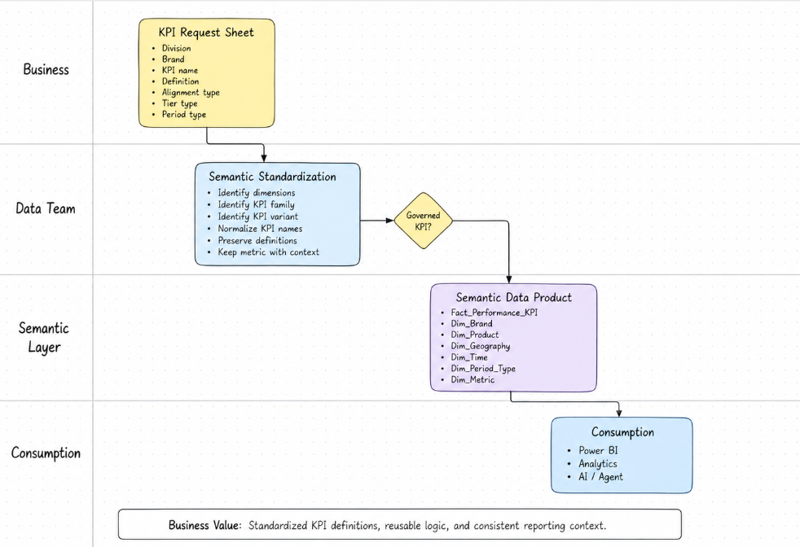
Proposed business grain
A good first-cut grain for this semantic product is:
One row per Division x Brand x Geography x Alignment Type x Tier Type x Master Profile x Period Type x Time x Product x Metric Family x Metric Variant
This is a design grain, not yet a final confirmed implementation grain. It is based on what is visible in the KPI screenshots and on the meeting feedback that the metric must stay connected to the business context rather than being split apart.

What value this adds
This semantic product adds value in a way the raw KPI sheet cannot.
It gives the business:
- one governed KPI structure,
- one place for metric meaning,
- one place for business context,
- reusable logic across dashboards,
- easier comparison across products and periods,
- a model that can later support AI and follow-up questioning.

This directly matches the meeting feedback that the model must standardize the measures in the semantic layer so dashboards do not have to keep recalculating logic again and again.

Final summary
This KPI sheet is best treated as a business KPI framework, not as the final data model.
The semantic data product should take that framework and turn it into:
- one governed KPI fact structure,
- a set of conformed business dimensions,
- a clean metric catalog with business definitions,
- and a reusable performance layer for BI, analytics, and AI.

